
Subscription:
ECA Ocean Racing European Championship – ECA Ocean racing Europa Cup 2016:

* Name _________________
* Surname _________________
* Date of Birth _______ Age ____ Category _____________
* Federal ID canoe card N° ______
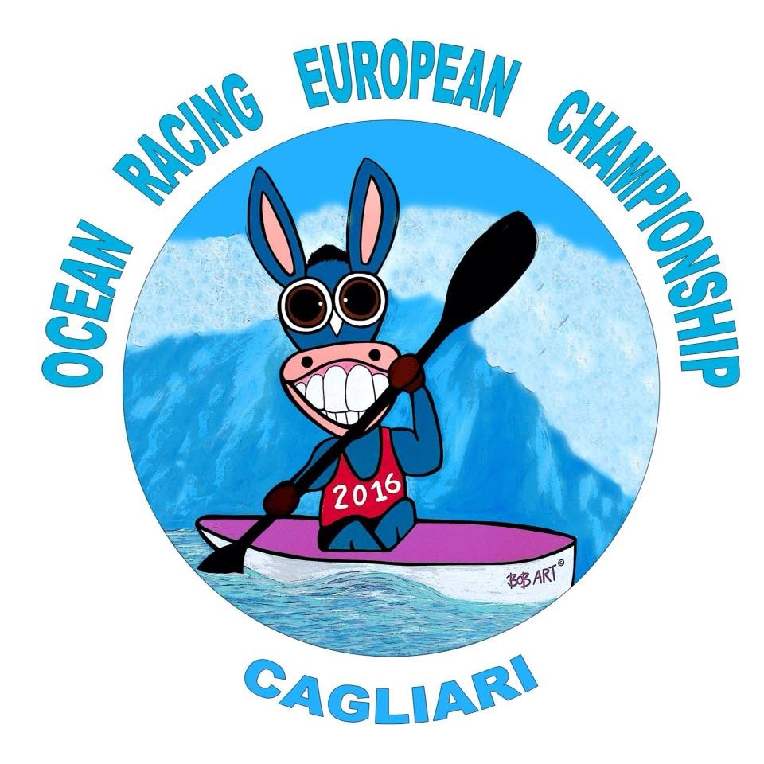
from: _______ Expiration day ___________
* Address ___________
* Town __________ zip__________
* Country _________
* T-shirt- Size _______
* Mobile number _______

Important!
(* ) Required field.

To register you must send this subscription by email to kaunateam@tiscali.it until 8th september 2016 and a copy of Bank payment of 85,00 euros (later the subscription isn’t possible).
To finish the register is necessary after the registration, send a photo in JPG, to this email : kaunateam@tiscali.it indicating in the email your Name.
All individual registrations must be confirmed by the National Federation before the end of the deadline.
Only registrations confirmed by National Federation will be considerated.
You have to pay the submission by bank at:
ASD Kauna Team
Unicredit Banca: IBAN-: IT36T0200804811000010939979
BIC/SWIFT : UNCRITM1E61

Liability Waiver:

(Must READ and SIGN to participate)

Cagliari, 20/25 september 2016

In consider of my entry in the “ECA Ocean Racing European Championship & ECA Ocean Racing Europa Cup” 20th to 25th of september 2016, I for myself waive and release any and all rights and claims including any claims for negligence I may have or accrue against any organization member of the “A. S. D. KAUNA TEAM”, the safety/water/support division and any other regatta’s sponsor or co-sponsor or their representative, agents, successors, and assigns for any and all damages or injuries or death which may suffered as a result of my participation in this event.
I understand I will be paddling in an uncontrolled environment in an open-sea waters and that death or serious injury could occur due to unforeseeable circumstances.
I attest and verify that I am physically fit and sufficiently trained for the competition of this race. I am completely and solely responsible for my own safety. I understand that the race will be covered using general photographic, film, and/or video cameras and may be televised. By signing this entry, I release all rights or proprietary claims for the use of my image or voice to be photographed, videotaped or filmed for commercial or any other purposes. I authorize the unconditional use of my image or voice in any form while participating in this event.

------------------------------------------- ---------------------------
Participant’s Signature
Date
-----------------------------------------
Print Name

